Data Pre-processing and Training
For Training we have used the Data from the popular BraTS Dataset, modifying it slightly to our convenience.
In the BraTS Dataset, each image consists of four modalities. These modalities are essentially different representation of the same brain image, but containing different types of information as they are captured through different criterion. These modalities are called T1, T1CE(T1 Contrast Enhanced), T2, and Flair. All the modalities for each date are present in the dataset in the form of .nii flies, along with the ground-truth mask which is also present in .nii file format.
  - Data Preprocessing
For processing this data prior to training we first ditched the T1 modality entirely, as T1CE is just the contrast enhanced version of T1, leading to it having almost all the information that T1 holds and some more due to it being contrast enhanced. This meant we can reduce 25% size for each data while loosing little to no useful information.
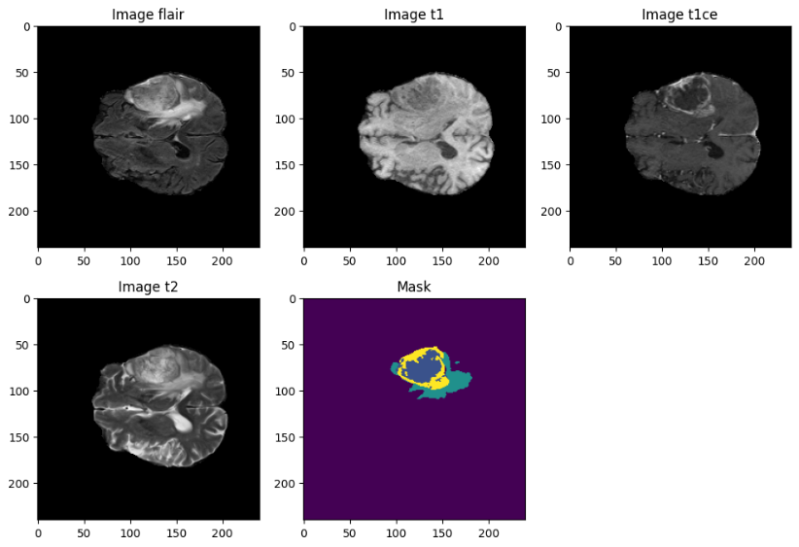
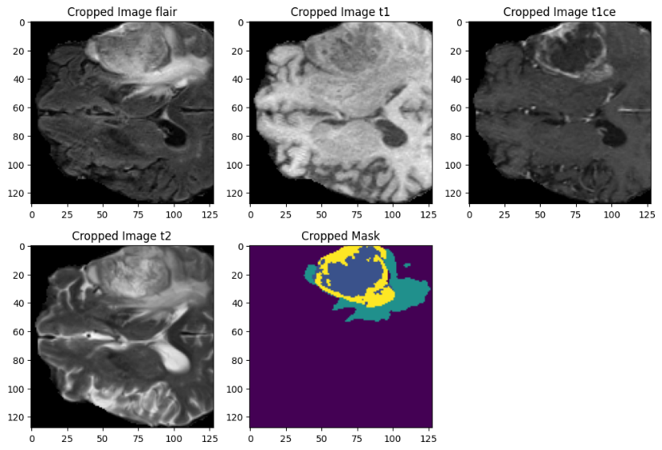
For the remaining 3 modalities(T1CE, T2 and Flair) we first cropped each modality from a size of 240x240x155 to 128x128x128. Now theoretically this may also lead to loosing so essential information from the data. But even after doing this hard crop we retain almost all the image information. This is shown through the following example:

In this we are seeing exactly the middle slice of an example data. Being the middle slice this is the worse case scenario of how the crop effects the data, as the brain can’t be any wider in any other portion. As even in the widest part of the brain more than 90% of the data is still present, and almost all off the ground truth mask is present. This means we can make a rough estimate that >97% of the useful data is still present. Through cropping we are discarding the black empty portion around the brain, making the date more light weight and easier to handle. We determined losing some of the brain in our training data would be an effective trade-off as even if we feed the model uncropped data afterwords when the training is done, it predicts the ground truth mask with effectively same accuracy.
Also this cropping we very useful as it brings the size of each dimension in the order of 2^{n}, which is consider to be the best practice for any data that is being fed to a network with multiple maxpooling layers.
These .nii files are then converted into numpy arrays of size 128x128 x128x3 and stored on the hard disk as .npy files.
For the ground truth masks they consist four labels: Unlabelled volume (Label 0), Necrotic and non-enhancing tumour core (NCR/NET) (Label 1), Peritumoral edema (ED) (Label 2), GD Enhancing Tumour (ET) (Label 4). Now the ground truth masks have a problem. The ET is ladled as 4 and label 3 is empty. Even though it is not supposed to cause any problems in the training, but just to mitigate the inconsistency, while processing we reassign the ET region from label 4 to label 3 and the data points in the mask files are then one hot encoded and stored as int8 in a numpy array. We store that numpy array in the hard disk as .npy file to use during training.
Another preprocessing step we take is to discard the data where less than 1% of the volume is covered by the mask, meaning if a data has less than 1% tumour volume, then we discard that data point entirely**.
We combined the BraTS 2020 and BraTS 2021 datasets to obtain a lager dataset. About 1400+ volumetric scan were present in the combined dataset; after applying this discarding criterion, ~1200 valid image-mask pairs remain.
The mean file size of a NumPy files for a single image array is approximately 64 MB, and the corresponding mask array occupies roughly 48 MB.
During training, the data are read on-the-fly via a Python generator, which yields a tuple (X,Y); X,Y being an image-Mask pair. This approach avoids loading the entire dataset into memory and makes it possible to train with batch size of 1 to 3. The generator also performs random shuffling of the dataset at the beginning of each epoch***.
For training and development, we utilized multiple GPUs depending on availability, including RTX 3060 Ti Mobile (8 GB VRAM), Titan X Pascal (12 GB VRAM), Quadro P5000 (16 GB VRAM) and Tesla T4 GPU on Google Colab(16GB VRAM). Due to the limitations of the older Quadro P5000 architecture, we faced some problems in handling the computational demands of 3D convolutions. To mitigate memory constraints across all devices, we adopted mixed precision training, which reduces tensor size and thereby alleviates VRAM usage. Even with this optimization, the maximum feasible batch size across all GPUs was limited to 2, the 3060 Ti Mobile had to use a batch size of 1.
Approximate GPU VRAM Usage is ~11 GiB for a batch Size of 2 and ~13.5GiB for a Batch Size of 3. Average inference times per batch are 0.8853 s and 1.3295 s for a 2-volume batch and a 3-volume batch respectively; Average inference times per volume are 0.4427s and 0.4432 s for a 2-volume batch and a 3-volume batch respectively*.
The hyperparameters for the training are as reported below****:
Learning Rate: 0.0001 Optimizer: Adam Epochs: 150 Batch Size: 2
For the loss function we used an adaptive combination of Dice Loss and Categorical Focal Loss. That adaptive loss function is explained in the section below.
Loss Function
The choice of an appropriate loss function is critical for medical image segmentation, particularly in highly imbalanced tasks such as brain tumour segmentation, where foreground tumour regions often occupy a very small fraction of the overall volume. In this work, we design an Adaptive Loss Function that combines Dice Loss with Categorical Focal Loss, dynamically adjusting their relative contributions as training progresses.
Dice Loss
The Dice coefficient directly measures the overlap between predicted and ground truth masks. For multi-class segmentation, the Dice Loss is defined as:
$$L_{Dice}=1-\frac{2\sum_{i=1}^{N}{\sum_{c=1}^{C}{y_{i,c}{\hat{y}}_{i,c}}}}{\sum_{i=1}^{N}{\sum_{c=1}^{C}{y_{i,c}^{2}}}+\sum_{i=1}^{N}{\sum_{c=1}^{C}{{\hat{y}}_{i,c}^{2}}}+ϵ}$$
Where $y_{i,c}∈\left\{0,1\right\}$ is the ground truth one-hot encoded label for voxel $i$ in class $c$, ${\hat{y}}_{i,c}$ is the predicted softmax probability, N is the number of voxels, C the number of classes, and $ϵ$ a small constant for numerical stability.
Dice Loss encourages overlap between predicted and ground-truth masks, and is particularly effective at handling class imbalance
Categorical Focal Loss
To further address the imbalance and focus learning on difficult-to-classify voxels, we employ the Categorical Focal Loss (adapted from Lin et al., 2017):
$$L_{Focal}=-\frac{1}{N}\sum_{i=1}^{N}{\sum_{c=1}^{C}{α_{c}{\left(1-{\hat{y}}_{i,c}\right)}^{γ}y_{i,c}\log\left({\hat{y}}_{i,c}\right)}}$$
Here, $γ>0$ is the focusing parameter that reduces the relative loss contribution of well-classified voxels, while $α_{c}$ is a balancing factor for class $c$.
Adaptive Weighting Strategy and The Final Loss
Rather than fixing the relative importance of Dice and Focal losses, we introduce a dynamic weighting scheme that changes over epochs. Let $t$ denote the current epoch, then the weights are defined as:
$w_{Dice}\left(t\right)=\frac{1}{1+exp\left(-βt\right)}$ and $w_{Focal}\left(t\right)=1-w_{Dice}\left(t\right)$
Where $β$ controls the smoothness of the transition. Early in training, the model emphasizes Focal Loss to tackle hard examples and improve class discrimination. As training progresses, the weight shifts towards Dice Loss, ensuring that fine-grained segmentation quality and overlap improve.
The final adaptive loss is then given by:
$$L_{Adaptive}\left(t\right)=w_{Dice}\left(t\right)L_{Dice}+w_{Focal}\left(t\right)L_{Focal}$$
This adaptive scheme enables a balanced optimization process, starting with robust class-level discrimination and gradually shifting toward maximizing spatial overlap between predicted and ground truth tumour regions.

Result and Comparison
We evaluated our proposed U-Net variant on the merged BraTS 2020 and 2021 training sets. A 75/25 split was applied, with 25% of the cases held out for validation
Training continued up to epoch 152, with validation loss and segmentation metrics tracked throughout. We report both the best values observed during training and the final results at epoch 152. Best values reflect the model's peak capability, which could be recovered through checkpoint selection or ensembling.
Metric (validation) | Best (value, epoch) | Final (value, epoch 152)
Validation loss (lower better) | 0.130518 (142) | 0.138168 (152)
Validation accuracy | 0.988855 (90) | 0.987859 (152)
Mean IoU (one-hot mean) | 0.592392 (149) | 0.584321 (152)
IoU score | 0.824554 (142) | 0.795915 (152)
F1 score | 0.962600 (104) | 0.927219 (152)
Precision | 0.969964 (80) | 0.943784 (152)
Recall | 0.974056 (114) | 0.911534 (152)
Dice (TC)***** | 0.983462 (104) | 0.958690 (152)
Dice (WT)***** | 0.946574 (145) | 0.845925 (152)
Dice (ET)***** | 0.953780 (142) | 0.905504 (152)
Macro Dice (average) | 0.950610 (104) | 0.903373 (152)

These results show balanced and strong performance across tumor subregions, with highest stability for Tumor Core (TC) and consistently solid scores for Enhancing Tumor (ET). Dice WT displayed a larger gap between best and final, highlighting greater sensitivity to checkpoint selection and training dynamics. The best performance the model provides is for the TC region. That confirms our proposed dense residual-inception blocks and attention modules are well capable of robust segmentation. The achieved dice score for ET and WT being 0.9055 and 0.8459 respectively and their peak being 0.9538 and 0.9466 shows that model is well capable segmenting small and heterogeneous classes, but we need to be better at checkpoint selection rather than training the model for a set amount of epochs.
Below are the provided graphs for each results:
[Insert Charts Here]

Also below are provided some of the sample segmentation, produced by the final trained model-
[Insert Segmentation images Here]

Comparing other popular networks to our proposed model-
Model (dataset / year) | WT Dice | TC Dice | ET Dice | Source
Myronenko (BraTS 2018) | 0.884 | 0.815 | 0.766 | Myronenko, 2018 — BraTS 2018 test: WT 0.8839, TC 0.8154, ET 0.7664.
Two-Stage Cascaded U-Net (BraTS 2019 winner) | 0.888 | 0.837 | 0.833 | Jiang et al., Two-Stage Cascaded U-Net — BraTS 2019 test: WT 0.88796, TC 0.83697, ET 0.83267.
nnU-Net (BraTS 2020 champion) | 0.890 | 0.851 | 0.820 | Isensee et al., nnU-Net — BraTS 2020 test: WT 0.8895, TC 0.8506, ET 0.8203.
TransBTS (Transformer + CNN, 2021) | 0.900 | 0.819 | 0.789 | Wang et al., TransBTS — reported (after TTA) ET 0.7893, WT 0.9000, TC 0.8194. (paper lists ET, WT, TC in that order).
Swin UNETR (Swin transformer hybrid, 2022) | 0.926 | 0.885 | 0.858 | Hatamizadeh et al., Swin UNETR — validation: ET 0.858, WT 0.926, TC 0.885.
SwinBTS (Swin Transformer 3D, 2022) | 0.918 | 0.848 | 0.832 | Jiang et al., SwinBTS — reported ET 0.8321, TC 0.8475, WT 0.9183.
BiTr-UNet (CNN+Transformer, BraTS 2021) | 0.926 | 0.935 | 0.887 | Jia et al., BiTr-UNet — BraTS 2021 test: WT 0.9257, TC 0.9350, ET 0.8874.
Triplanar ensemble / BrainTumor-U (BraTS 2020) | 0.890 | 0.840 | 0.810 | Sundaresan et al., Triplanar ensemble — BraTS 2020 test: ET 0.81, WT 0.89, TC 0.84.
S3D-UNet (Separable 3D U-Net, 2018) | 0.839 | 0.783 | 0.689 | Chen et al., S3D-UNet — reported test/validation results: ET 0.6895, WT 0.8389, TC 0.7835.
Cascaded V-Nets (BraTS 2018 results) | 0.876 | 0.795 | 0.736 | Hua et al., Cascaded V-Nets — BraTS 2018 test: WT 0.8761, TC 0.7953, ET 0.7364.
Our model (this work, merged BraTS 2020+2021, 75/25 val) | 0.846 | 0.959 | 0.906 | Validation logs (this work), final epoch 152 (WT 0.8459, TC 0.9587, ET 0.9055).

On validation, our model ranks among top performers for TC and ET, with Dice scores of 0.959 and 0.906 respectively. While WT Dice was 0.846 at the final epoch—slightly lower than models reporting >0.90—our peak WT Dice reached 0.947, indicating checkpointing or ensembling could close this gap. Overall, the model delivers competitive performance, particularly for TC and ET segmentation, aligning with recent transformer-hybrid models.
Where out model really shines is it being light-weight. When we compare the parameter count of our model with others-

Model (ref) | Total parameters | Notes / source
Our model (this work) | 4,008,868 (4.01M) — trainable 4,008,868, non-trainable 0 | Reported for our architecture (given).
SegFormer3D (Perera et al., 2024) | 4.5 M | Lightweight transformer design, reported 4.5M. (CVF Open Access)
LightM-UNet / LightM-Unet (contemporary) | 5.02 M | Reported as a very lightweight baseline in SuperLightNet paper. (CVF Open Access)
3D U-Net (baseline) | 16.21 M | 3D U-Net parameter count cited by TransBTS authors for a canonical 3D U-Net configuration. (MICCAI 2021)
VT-UNet-B (survey value) | 20.8 M | Reported in transformer survey table for VT-UNet-B. (ResearchGate)
TransBTS (Wang et al., 2021) | 32.99 M | TransBTS reported at 32.99M parameters. (MICCAI 2021)
nnU-Net (default configs) | ~30 M | Default nnU-Net configurations are commonly reported at roughly 30M parameters, specific count depends on dataset and chosen config. (OpenReview, GitHub)
nnFormer (survey value) | 39.7 M | Reported in transformer survey comparisons. (ResearchGate)
Swin UNETR (Hatamizadeh et al., 2022) | 61.98 M | Swin UNETR parameter count from the original paper. (arXiv)
UNETR (Hatamizadeh et al., 2021) | 102.5 M | UNETR reported as a large ViT-based encoder configuration, ~102.5M in survey comparisons. (ResearchGate)

Our model ranks as some of the most light weight model out there.
Even if we compare the FLOPs count of our model-
Methods | Parameters (M) | FLOPs (G)
3D U-Net | 7.74 | 586.71
Attention U-Net | 17.12 | 588.26
VNet | 7.03 | 769.30
Swin-Unet | 27.15 | 250.88
HDC-Net | 0.29 | 25.62
TransUNet | 105.18 | 1,205.76
TransBTS | 30.61 | 263.82
MCSLF-Net | 24.49 | 142.43
Reported as per Mingzhe Zhou et al., we can see this model might not rank among the Ultra-Lightweight models like HDC-Net. But we can comfortably place it in the category of light weight model.

Conclusion
This proposed model performs on per or even better than main stream image segmentation architecture, managing to compete with popular Transformer based networks, while being much lightweight than most of them.
In this paper we have not shown justifications for many of the improvements that we have made. For example we have not shown any evidence that our adaptive loss function works better than other mainstream loss functions like Tversky or Boundary loss; or even if it works better than Dice Loss or Categorical Focal Loss stand alone. Also in case of our DRIC block we have not formally tested if all components of that block is strictly necessary, or how it preforms compared to already available/popular Dense, Residual, or Inception block. These components of the architecture has been decided through an theoretical understanding and through preliminary small-scale testing. We have failed to show any justification for them mostly due to a lack of equipment and a lack of scope. Also we haven’t tested other criterions that could have theoretically boosted our model performance; for example other validation strategies like cross-validation or hold-out, Data Augmentation strategies, Other normalization approach etc. We how to experiment with them in future expansion of the work, if the scope permits.

*N.B.: The VRAM usage and inference times are reported as per partial test runs on Google Colab, using a Tesla T4 GPU.
**N.B. & ***N.B.: These processes are adopted directly from YouTube tutorials of Dr. Sreenivas Bhattiprolu ("Digital Srini" on YouTube).
****N.B.: Reported as per the final run.
*****N.B.: Abbreviations Used here are; TC- Necrotic and non-enhancing tumour core[Lebel 1], WT- Peritumoral Edema[Lebel 2], ET- GD Enhancing Tumour[Lebel 3]

